

# Below Property can be used to read API query, but for OData API name is not coming (Need to explore how to get OData API name)

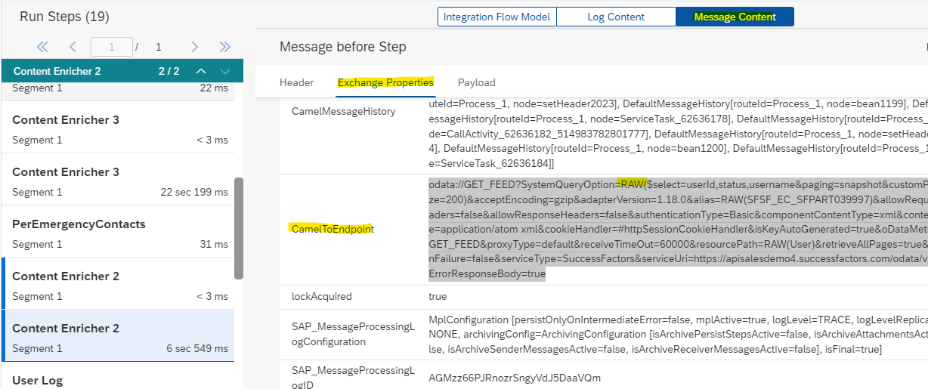

Property – CamelToEndpoint holds the value

|  |
| --- |
| sap-successfactors://CompoundEmployee?address=https%3A%2F%2Fapisalesdemo4.successfactors.com%2Fsfapi%2Fv1%2Fsoap&alias=SFSF_EC_SFPART039997&authenticationType=Basic&batchSize=200&bus=%23sfsfBus&cookieHandler=%23httpSessionCookieHandler&entity=CompoundEmployee&id=Receiver1SuccessFactors_CE&messageProtocol=SOAP&operation=querySync&query=SELECT+person%2C+email_information%2C+employment_information%2C+compensation_information%2C+paycompensation_recurring%2C+job_information%2C+paycompensation_non_recurring%2C+phone_information+FROM+CompoundEmployee+where+person_id_external+IN+%28%27100009%27%2C%27100052%27%2C%27100113%27%29&queryMode=NORMAL&receiveTimeOut=60000&secureStore=%23sfsfSecureStore&sfsfServiceProvider=%23sfsfServiceProvider&trustManagers=%23sfsfTrustManagers&usrDefinedNamespaceMap=%23userdefinedNamespaces |
| odata://GET_FEED?SystemQueryOption=RAW($select=userId,status,username&paging=snapshot&customPageSize=200)&acceptEncoding=gzip&adapterVersion=1.18.0&alias=RAW(SFSF_EC_SFPART039997)&allowRequestHeaders=false&allowResponseHeaders=false&authenticationType=Basic&componentContentType=xml&contentType=application/atom xml&cookieHandler=#httpSessionCookieHandler&isKeyAutoGenerated=true&oDataMethod=GET_FEED&proxyType=default&receiveTimeOut=60000&resourcePath=RAW(User)&retrieveAllPages=true&retryOnFailure=false&serviceType=SuccessFactors&serviceUri=https://apisalesdemo4.successfactors.com/odata/v2&setErrorResponseBody=true |
| odata://GET_FEED?SystemQueryOption=RAW($select=personIdExternal,secondPhone,phone,primaryFlag&paging=snapshot&customPageSize=200)&acceptEncoding=gzip&adapterVersion=1.18.0&alias=RAW(SFSF_EC_SFPART039997)&allowRequestHeaders=false&allowResponseHeaders=false&authenticationType=Basic&componentContentType=xml&contentType=application/atom xml&cookieHandler=#httpSessionCookieHandler&isKeyAutoGenerated=true&oDataMethod=GET_FEED&proxyType=default&receiveTimeOut=60000&resourcePath=RAW(PerEmergencyContacts)&retrieveAllPages=true&retryOnFailure=false&serviceType=SuccessFactors&serviceUri=https://apisalesdemo4.successfactors.com/odata/v2&setErrorResponseBody=true |

# Below section also fetching some information about the API (Need to explore how to read it through)

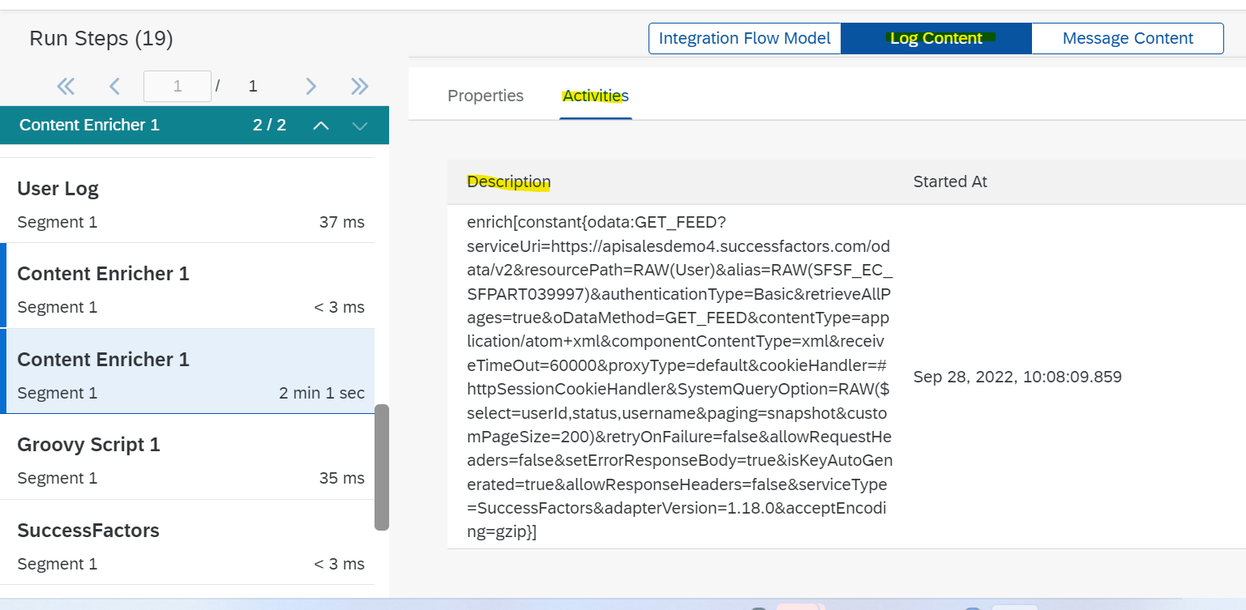

|  |
| --- |
| sap-successfactors:CompoundEmployee?entity=CompoundEmployee&messageProtocol=SOAP&operation=querySync&receiveTimeOut=60000&alias=SFSF_EC_SFPART039997&batchSize=200&address=https://apisalesdemo4.successfactors.com/sfapi/v1/soap&id=Receiver1SuccessFactors_CE&queryMode=NORMAL&query=SELECT person, email_information, employment_information, compensation_information, paycompensation_recurring, job_information, paycompensation_non_recurring, phone_information FROM CompoundEmployee where person_id_external IN ('100009','100052','100113')&authenticationType=Basic&trustManagers=#sfsfTrustManagers&sfsfServiceProvider=#sfsfServiceProvider&secureStore=#sfsfSecureStore&bus=#sfsfBus&usrDefinedNamespaceMap=#userdefinedNamespaces&cookieHandler=#httpSessionCookieHandler |
| enrich[constant{odata:GET_FEED?serviceUri=https://apisalesdemo4.successfactors.com/odata/v2&resourcePath=RAW(User)&alias=RAW(SFSF_EC_SFPART039997)&authenticationType=Basic&retrieveAllPages=true&oDataMethod=GET_FEED&contentType=application/atom+xml&componentContentType=xml&receiveTimeOut=60000&proxyType=default&cookieHandler=#httpSessionCookieHandler&SystemQueryOption=RAW($select=userId,status,username&paging=snapshot&customPageSize=200)&retryOnFailure=false&allowRequestHeaders=false&setErrorResponseBody=true&isKeyAutoGenerated=true&allowResponseHeaders=false&serviceType=SuccessFactors&adapterVersion=1.18.0&acceptEncoding=gzip}] |
| enrich[constant{odata:GET_FEED?serviceUri=https://apisalesdemo4.successfactors.com/odata/v2&resourcePath=RAW(PerEmergencyContacts)&alias=RAW(SFSF_EC_SFPART039997)&authenticationType=Basic&retrieveAllPages=true&oDataMethod=GET_FEED&contentType=application/atom+xml&componentContentType=xml&receiveTimeOut=60000&proxyType=default&cookieHandler=#httpSessionCookieHandler&SystemQueryOption=RAW($select=personIdExternal,secondPhone,phone,primaryFlag&paging=snapshot&customPageSize=200)&retryOnFailure=false&allowRequestHeaders=false&setErrorResponseBody=true&isKeyAutoGenerated=true&allowResponseHeaders=false&serviceType=SuccessFactors&adapterVersion=1.18.0&acceptEncoding=gzip}] |
| enrich[constant{odata:GET_FEED?serviceUri=https://apisalesdemo4.successfactors.com/odata/v2&resourcePath=RAW(User)&alias=RAW(SFSF_EC_SFPART039997)&authenticationType=Basic&retrieveAllPages=true&oDataMethod=GET_FEED&contentType=application/atom+xml&componentContentType=xml&receiveTimeOut=60000&proxyType=default&cookieHandler=#httpSessionCookieHandler&SystemQueryOption=RAW($select=userId,status,username,firstName,lastName&$filter=(status eq 'active' or status eq 'inactive')&paging=snapshot&customPageSize=200)&retryOnFailure=false&allowRequestHeaders=false&setErrorResponseBody=true&isKeyAutoGenerated=true&allowResponseHeaders=false&serviceType=SuccessFactors&adapterVersion=1.18.0&acceptEncoding=gzip}] |